Nepal College of Information Technology
Unit Test
Fall 2013
Program : BE ELX Time : 2 hrs
Semester : (I) FM : 70
Subject : Engineering Mathematics-I PM : 35

- Candidates are requested to give their answer as far as practicable in their own words.
- The figure in the margin indicates the full marks
- Attempt ALL question

1. a) A function is defined as follows ,
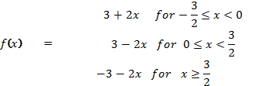
Show that f(x) is continuous at x=0, and discontinuous at x=3/2. 7
b) A function is defined as follows,
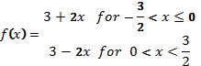
Show that f(x) is continuous at x=0 but not derivable at that point. 8
2. a) If ,show that
- 7
b) State Rolle's Theorem theorem and verify it for
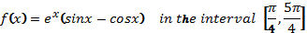 8
3. Integrate following,(any three) 15
a) 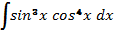
b) 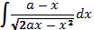
c 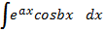
d) 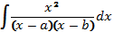
4. Integrate following,(any three) 15
a) 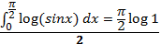
b) 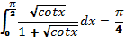
c)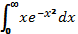
d) Reduction formula for 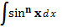
5. Answer following 10
i) Find the points where 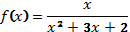 is discontinuous.
ii) 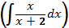
iii) 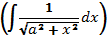
iv) 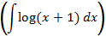
v) 